

**Anchorwood Limited**

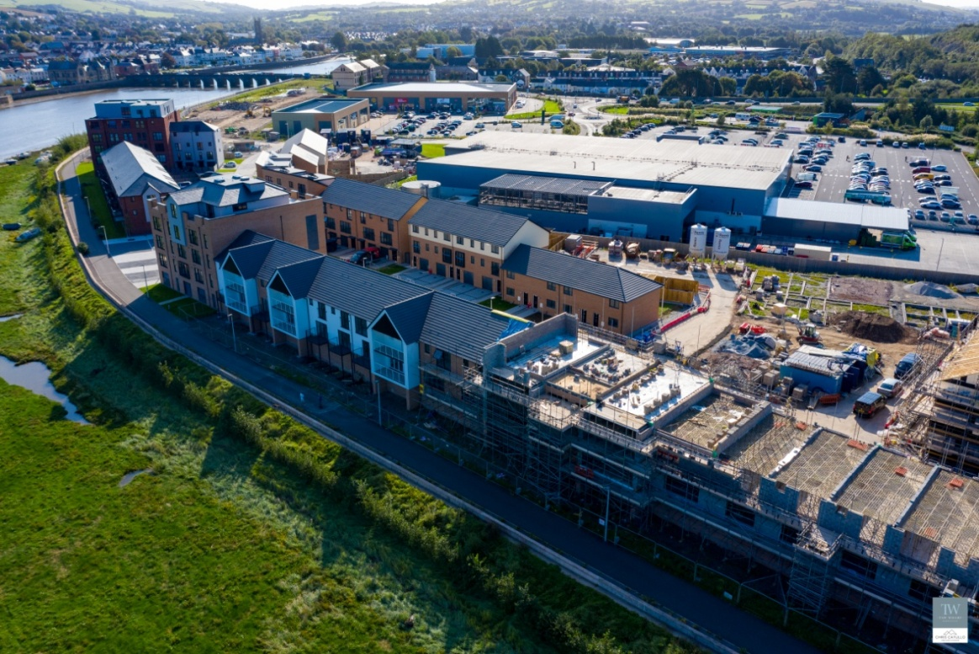

Non-Executive Board Director Application Pack



**Contents:**

**Welcome to Anchorwood**

# About North Devon

**Board of Directors**

# Corporate Values

# Application Guidelines

**Equal Opportunities**

**Governance**

**General Data Protection Regulations**

# Welcome to Anchorwood

Thank you for showing interest in joining the board

of Anchorwood. We are an ethical

development company working in the south west,

delivering new homes and building communities

where people want to live. As a business we

welcome investment into the south west and want

to use the beautiful area and location to deliver

high quality new homes. This enables us to help

provide funds for building affordable homes and

tackling the housing crisis.

We have built a great team here, and I look forward

to meeting you to talk about how your skills and experience

can enhance and develop our business going forward.

*Simon Sanger-Anderson*

Some quick things you need to know about us :

* Anchorwood is a wholly-owned subsidiary of North Devon Homes.
* Anchorwood is an ethical property developer that seeks to deliver high quality homes in the right locations to help build communities where people want to live.
* The Board of 7 oversees the market sale delivery of approximately 100 homes a year.
* North Devon Homes is a registered housing association with approximately 3,300 homes.
* We work together as a team to achieve our commercial objectives.
* Our operating area covers Devon.
* We work closely with local developers and partners to deliver new housing through joint ventures.
* Our head office is based at Westacott Road, Barnstaple, Devon EX32 8TA.
* We are currently developing 172 market sale new homes at Taw Wharf <https://www.taw-wharf.co.uk> by 2025 and plan to deliver a steady programme of market sales homes a year thereafter.
* You can find out more about the work of the group by visiting our website: <https://www.ndh-ltd.co.uk/who-we-are/anchorwood-limited>
* We are looking for experienced property professionals who are able to see the bigger picture and help us deliver our ambitious plans in a challenging market.
* In terms of your commitment to us - we normally hold five board meetings annually and they last two hours. In addition to these meetings, we would want you to attend about eight workshops, seminars or training sessions (depending on your experience) throughout the year which are optional. Most meetings are currently on line and typically last 2 hours.
* We also make some meetings face to face (two face to face Board meetings planned for 2024) and there would be a requirement to attend the induction, risk or strategy meetings in person during the year.

# About North Devon

With its breathtaking countryside and unspoilt beaches, it is easy to see why North Devon is one of the country’s most beautiful and increasingly popular holiday destinations. Those of us living and working here get to enjoy it every day – what could be better than that?



North Devon is highly desirable and attracts a lot of visitors and people keen to find a home in the area. Anchorwood seeks to deliver new, high quality homes for the area which are developed in an ethical way. This means that the profits made from delivering these homes are re-invested in providing affordable housing for the community of North Devon. The delivery of our new homes has a positive impact on the local communities, economy and promotes sustainable communities.

If you want to know more about the area we operate in, please visit:

[www.northdevon.com](http://www.northdevon.com/)

# Board of Directors

The Anchorwood board consists of six current members plus one vacancy

|  |  |  |
| --- | --- | --- |
|  |  |  |
| **Simon Sanger-Anderson, Chair** | **Paul Matton** | **Asad Butt** |
|  |  |  |
| **Delyth Lloyd-Evans new.JPG** |  |  |
| **Delyth Lloyd-Evans** | **Scott Murray** | ***Geoff Fox*** |
|  |  |  |
|  |  |  |
|  |  |  |
| ***Vacancy*** |  |  |

**Corporate Values**

We call our values the ‘FACTS’ and these help shape our culture. When we are recruiting, we look for people who share similar values to us and who are able to add value to our team.

If you share these values, we would love to hear from you!

**F**lexible in our approach

**A**ccountable to our customers and each other

**C**ompassionate, professional and polite

**T**eam NDH working together

**S**ervice Excellence

**Application Guidelines**

Please read these notes before you complete the application form and submit your CV.

* The Application Form has two parts. The main Application Form which is used for short-listing and interviewing along with your CV and the Equal Opportunities Form which is required by Human Resources for administrative and equal opportunities monitoring purposes.
* The Equal Opportunities Form will not be seen by those who shortlist and will only be available to Human Resources.

When completing your application, please remember:

* think carefully about the skills, knowledge and experience outlined in the job description and ensure your CV and supporting statement reflects the requirements of the role.

* that submitting an application indicates that the information provided is correct.
* your CV must include previous employment details, dates and reason for leaving, education and qualification details.
* to check for accuracy, particularly with dates of previous employment, details of qualifications.
* to provide examples and supporting evidence to demonstrate relevant qualities and skills.
* In line with our equal opportunities policy, please do not include any personal details on your CV.
* We will ensure that no potential or actual employee receives less favourable treatment on the grounds of age, disability, gender, gender reassignment, race, religion or belief, pregnancy or maternity, marital or civil partnership status or sexual orientation.
* In accordance with employer obligations under the Equality Act, applicants with disabilities can contact us to enquire about the circumstances of the job and at interview; the selectors will discuss any special needs or reasonable adjustments required to enable applicants to fulfill the role.
* We welcome applications from disabled candidates and guarantee to interview all disabled applicants who meet the minimum criteria for the vacancy.
* We are proud to be a disability confident Employer. The disability confident scheme is a recognised scheme set up by the government to challenge attitudes, increase understanding of disability, remove barriers, and ensure that disabled people have the opportunities to fulfill their potential and realise their aspirations.

Anchorwood Limited reserves the right to verify any information provided. Falsifying or deliberately omitting information will result in automatic disqualification from the selection process or dismissal on the grounds of gross misconduct, whichever is appropriate.

**Right to work**

For Home Office regulations, you will be required to provide proof of your eligibility to work in the UK prior to an offer of employment from Anchorwood.

Acceptable documentation is as follows:

* EU or British passport
* **Full** UK birth certificate **and** proof of National Insurance number
* Passport including relevant visa/stamps to work in the UK or remain in the UK.

For further information please visit [www.ukba.homeoffice.gov.uk](http://www.ukba.homeoffice.gov.uk/)

Applications may be emailed to [**recruitment@ndh-ltd.co.uk**](mailto:recruitment@ndh-ltd.co.uk)

**Sent by post to**

Human Resources, North Devon Homes, Westacott Road, Barnstaple, Devon EX32 8TA

Tel: 01271 313385

# Equal Opportunities

Anchorwood Limited is committed to being an equal opportunities employer.

As an employer, we believe that our workforce should reflect the community that it serves and that all groups should be properly represented at all levels within the Company.

If you would like the form in large print on audio tape or CD or if English is not your first language and you need a translation we will endeavour to arrange this for you.

# Induction & Training

If you are appointed you can expect an induction and training on the Company and support to help you get to know the role and the team.

We have a formal appraisal process and any training needs will be identified and supported as part of the initial induction.

# Governance

There are strict rules in terms of conflicts of interest and the receipt of any payment, grant or loan from any funds associated with the employer except under a contract of employment or as reimbursement for legitimate expenses.

# General Data Protection Regulation

**Data controller**: North Devon Homes, Westacott Road, Barnstaple, EX32 8TA

**Data protection officer**: Philippa Butler

As part of any recruitment process, North Devon Homes collects and processes personal data relating to job applicants. The organisation is committed to being transparent about how it collects and uses that data and to meeting its data protection obligations.

## What information does North Devon Homes collect?

The Organisation collects a range of information about you. This includes:

* your name, address and contact details, including email address and telephone number
* details of your qualifications, skills, experience and employment history
* whether or not you have a disability for which the Organisation needs to make reasonable adjustments during the recruitment process
* information about your entitlement to work in the UK
* equal opportunities monitoring information, including information about your ethnic origin, sexual orientation, health, and religion or belief.

The Organisation collects this information in a variety of ways. For example, data might be contained in application forms or CVs or obtained from your passport or other identity documents, or collected through interviews or other forms of assessment, including online tests.

The Organisation will also collect personal data about you from third parties, such as references supplied by former employers, information from employment background check providers and information from criminal records checks. The Organisation will seek information from third parties only once a job offer to you has been made and will inform you that it is doing so.

Your consent will be sought before contacting referees.

Data will be stored in a range of different places, including on your application record, in HR management systems and on other IT systems (including email).

## Why does the organisation process personal data?

The Organisation needs to process data to take steps at your request prior to entering into a contract with you. It also needs to process your data to enter into a contract with you.

In some cases, the Organisation needs to process data to ensure that it is complying with its legal obligations. For example, it is required to check a successful applicant's eligibility to work in the UK before employment starts.

The Organisation has a legitimate interest in processing personal data during the recruitment process and for keeping records of the process. Processing data from job applicants allows the organisation to manage the recruitment process, assess and confirm a candidate's suitability for employment and decide to whom to offer a job. The Organisation may also need to process data from job applicants to respond to and defend against legal claims.

Where the Organisation relies on legitimate interests as a reason for processing data, it has considered whether or not those interests are overridden by the rights and freedoms of employees or workers and has concluded that they are not.

The Organisation processes health information if it needs to make reasonable adjustments to the recruitment process for candidates who have a disability. This is to carry out its obligations and exercise specific rights in relation to employment.

Where the organisation processes other special categories of data, such as information about ethnic origin, sexual orientation, health, religion or belief, age, gender or marital status, this is done for the purposes of equal opportunities monitoring with the explicit consent of job applicants, which can be withdrawn at any time.]

The Organisation will seek information about criminal convictions and offences. Where the organisation seeks this information, it does so because it is necessary for it to carry out its obligations and exercise specific rights in relation to employment.

If your application is unsuccessful, the organisation will keep your personal data on file in case there are future employment opportunities for which you may be suited. The Organisation will ask for your consent before it keeps your data for this purpose and you are free to withdraw your consent at any time.

## Who has access to data?

Your information will be shared internally for the purposes of the recruitment exercise. This includes members of the HR team, interviewers involved in the recruitment process, line managers in the business area with a vacancy and IT staff if access to the data is necessary for the performance of their roles.

The Organisation will not share your data with third parties, unless your application for employment is successful and it makes you an offer of employment. The Organisation will then share your data with former employers to obtain references for you, employment background check providers to obtain necessary background checks and the Disclosure and Barring Service to obtain necessary criminal records checks.

The Organisation will not transfer your data outside the European Economic Area.

## How does the organisation protect data?

The organisation takes the security of your data seriously. It has internal policies and controls in place to ensure that your data is not lost, accidentally destroyed, misused or disclosed, and is not accessed except by our employees in the proper performance of their duties. Clear policies and procedures are in place and systems are restricted to those that require access as part of the recruitment process.

## For how long does the organisation keep data?

If your application for employment is unsuccessful, the organisation will hold your data on file for 12 months after the end of the relevant recruitment process. At the end of that period [or once you withdraw your consent], your data is deleted or destroyed.

If your application for employment is successful, personal data gathered during the recruitment process will be transferred to your personnel file and retained during your employment. A Staff Privacy Notice will be issued to all successful candidates as part of their offer pack.

## Your rights

As a data subject, you have a number of rights. You can:

* access and obtain a copy of your data on request
* require the organisation to change incorrect or incomplete data
* require the organisation to delete or stop processing your data, for example where the data is no longer necessary for the purposes of processing
* object to the processing of your data where the organisation is relying on its legitimate interests as the legal ground for processing; and
* ask the organisation to stop processing data for a period if data is inaccurate or there is a dispute about whether or not your interests override the Organisation's legitimate grounds for processing data.

If you would like to exercise any of these rights or make a subject access request, please contact Philippa Butler. Her email address is [dataprotection@ndh-ltd.co.uk](mailto:dataprotection@ndh-ltd.co.uk)

If you believe that the organisation has not complied with your data protection rights, you can complain to the Information Commissioner.

## What if you do not provide personal data?

You are under no statutory or contractual obligation to provide data to the organisation during the recruitment process. However, if you do not provide the information, the organisation may not be able to process your application properly or at all.

You are under no obligation to provide information for equal opportunities monitoring purposes and there are no consequences for your application if you choose not to provide such information.

## Automated decision-making

Recruitment processes are not based solely on automated decision- making.